Dominion – Post Mortem

Rohan Karnik, Bobby Blackburn, Matt Spraley, Ryan Simmons
rohankarnik@gatech.edu, bray123087@gmail.com, mspraley@me.com, thepedrog@gmail.com

ABSTRACT
The purpose of Dominion was to combine GPS technology with game design to create a game that was competitive and that combined Virtual and Physical Worlds. Michael Nitsche guided the project. We had a balanced group dynamic. Development of Dominion took 14 months.
This document covers the developer’s original vision for the game, the development cycle itself, as well as a reflection of the project as a whole after completion. The last part of this paper discusses the feel of the final version of the game by reviewing the screen flow.

1. INTRODUCTION
The game is played on any Android Device. A complimentary HTML5 webpage serves as a portal into the current game state as well.
In Dominion, one player creates a game and sets boundaries on the map. This defines the virtual and physical playground. Up to 5 players can join this game (for a total of 6). Players travel to various locations and “capture” the buildings by being near them and hitting the “Attack” button. Players can then attack and conquer other players’ buildings and destroy them in the virtual space. Once a player’s buildings are destroyed, he or she is out of the game. The last player standing wins.
Each player has a life-token, which is to be placed in any of the buildings. If the building with the life token is destroyed, the player of which it belongs to will automatically lose. Life-tokens can be moved at anytime without the player needing

2. VISION
We had an overall idea of what kind of game we wanted. Listed below is the top down goals of the project. Listed in sections 2.1 and 2.2 are the more specific goals.

1. Use GPS technology
2. Make it an Android App
3. Create a competitive RTS experience
4. Combine Digital and Physical Playgrounds
5. Build gameplay around player strategy and tactics

2.1 Design Goals
These are the more specific design

1. Clean and easy to use UI
2. HTML5 and android app go hand in had
3. Ability to attack, defend, & conquer buildings
4. A close to real time news feed system
5. Ability for the player to access their next move by looking at the big picture (my empire view)

2.2 Technical Goals
We had several technical goals that relied on successfully combining the virtual gameplay with the real locations. We wanted our players to be able to register a unique username, create a personal battlemap, and login into their account on both the Android and through a browser. We strived to utilize the Android GPS in a creative and efficient way to support fun gameplay. We planned to build and structure a type of gameplay largely based off time using a mySQL database and XML style sheets. We wanted to create a seamless gameplay that allowed for live updates to information within the app, including the conquering, defending, and attacking of buildings. As well as the Android app we aimed to create an HTML5 structured website that utilized AJAX and PHP to present live information about the player and the game in a similar fashion.

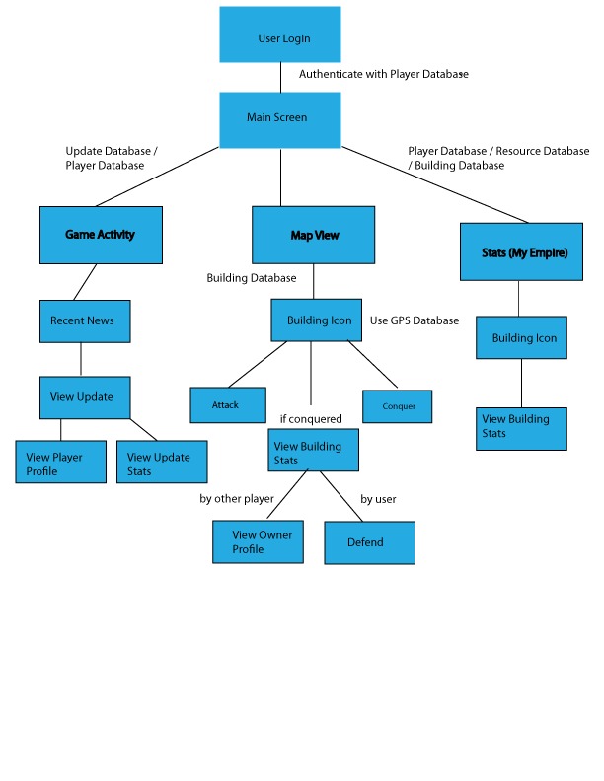

3. EXECUTION
Here we discuss the action development of the project starting from the team dynamic to the technical challenges met.

3.1 Team Dynamic
Bobby was the team manager and made sure that there were no communication errors across the group. Rohan was the lead designer and made sure the vision was kept in tact while moving forward with the project. Bobby and Rohan together came up with the UI as well as the details of the token system. Matthew and Ryan were our main engineers and without them we wouldn’t have a strong code base.

3.2 Design
At the start of the project, we didn't know exactly how Android supports different UI elements, such as new fonts, placing images, pop up menus, buttons, etc. since we were all new to Android development. As we figured out the specifics of the platform, we realized what kind of png files to put in while keeping the 'activities' working in the app. We changed the color theme to something more serious and futuristic while staying minimal. We streamlined the new game creation process and reduced the amount of screens needed to present all the information.
The main UI change between each version was the screen flow between different parts of the game, such as: where should we implement a pop-up vs moving to a new screen? We attempted to minimize the number of clicks and information necessary on each screen to make the game easier and more intuitive in relation to the major features of the game: Creating a new game, joining a game, as well as how a player accesses the attack, conquer, and defend actions.
The colors were gradually changed to blues and greys instead of the original yellows partly because we changed the system from a game designed specifically for GT campus to a game that could be played anywhere and wanted a more universal feel; thus, we wanted neutral colors that were cool and mechanical, easy on the eyes, that employ a more futuristic feel like Tron, and where the players provide the action in the game vs. using warm and active colors like violent reds or strong yellows that can be harsh on the eyes while staring at a small screen. We feel the colors in our final version seem more professional and "cool".

3.3 Technical
Our architecture consists of the Android phone and several activities talking to a mySQL database using external PHP files. We start out with 3 main activities that are consisting running since each one is essential to the game and don’t use that much memory and are only connecting to the database when necessary. The Map activity uses the most processing power and therefore has the least amount of extra GUI, however the My Empire View and and Recent Updates view have more GUI elements and connections to the database.
Our secondary classes included the login screen, the registration screen, and the create game screen. The login screen references a PHP file that receives the inputted credentials and checks them against the "user" table in the database. The registration screen sends the new user credentials to a PHP file where it creates a new row with the supplied input. Finally, the “create game” screen uses a basic map view and is dependent on PHP files as well. We chose not to use SQLlite because we wanted the PHP files to external so we can edit them dynamically without having always changed the actual Android app. We also used the 3 continuously running activities in order to have the data be seamless and remove unnecessary coding that deals with memory allocation. We also did not alternatively use the Web-View found in the Android SDK since the GUI was not native on the Android phone and we could cause extra hassle and less Android coding experience.

4. REFLECTION
Overall we are satisfied with the project. We did not have enough time to fully implement metrics nor did we have enough time to fully test out our game since we only had a number of android phones to work with. In the end we believe we met with the basic requirements set forth.

4.1 Design Goals Met
We wanted to combine virtual and physical playgrounds and we ended up just doing that. The user had to physically move to attack and defend buildings. We also implemented the element system which would give a sense of strategy to the player letting them use various tactics to win.
We learned that it is very hard to add incentive to the player without an immediate reward. The way we countered this was by always keeping pressure on the player via notifications and by playing up the fact that their territories were always in danger.

4.2 Technical Goals Met
We successfully implemented the Google Maps API to allow us to overlay specific Geopoints relating a current game. Each of these overlay graphics could be tapped to bring up extra information about the building. We also successfully tied three Android activities together to allow for seamless live updates in all three applications including the news feed, empire information, and the battlefield map. We also achieved the ability to store new locations and associate them with a specific game. Finally, we implemented an HTML5 website that allowed the user to view updates with greater detail, update their account information, view their personal statistics, and view global rankings.

5. TECHNICAL REVIEW
Below are brief summaries of how we implemented different parts of our game. The first screen the user sees is the main menu shown below.
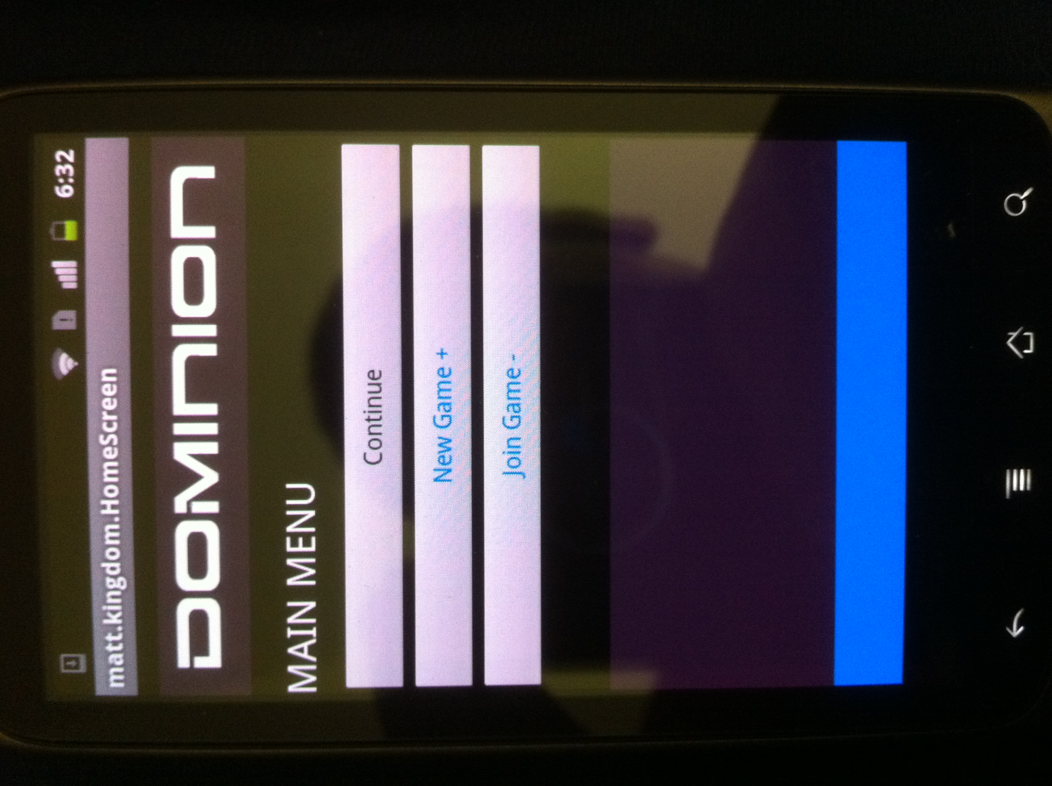

5.1 Create Game
When you create a new game, the user names the game, as well as inputs the first GPS coordinate making the first building. Below is the screen for capturing the GPS coordinate and naming the first location (or building)

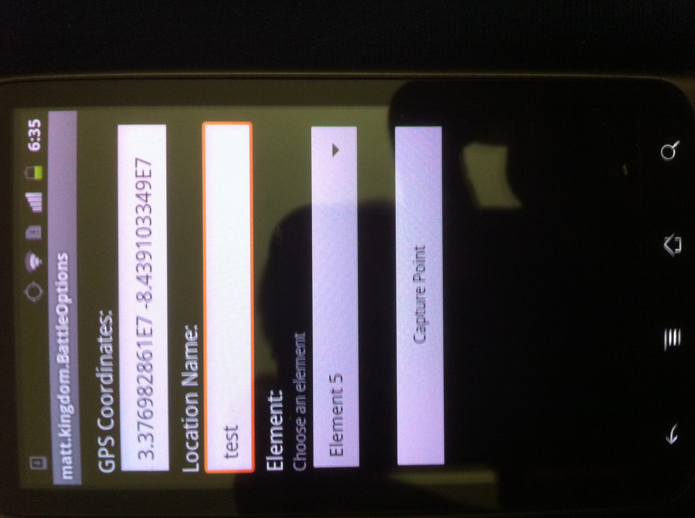

5.2 Map View
The battle map consists of a map-view class in Android and calls a PHP file that takes the "building table" and constructs an XML document that applies attributes and node values for each and every building that correspond to the current game the player is involved in. The XML results are then applied to a multidimensional array where they are stored to display the information on the screen.
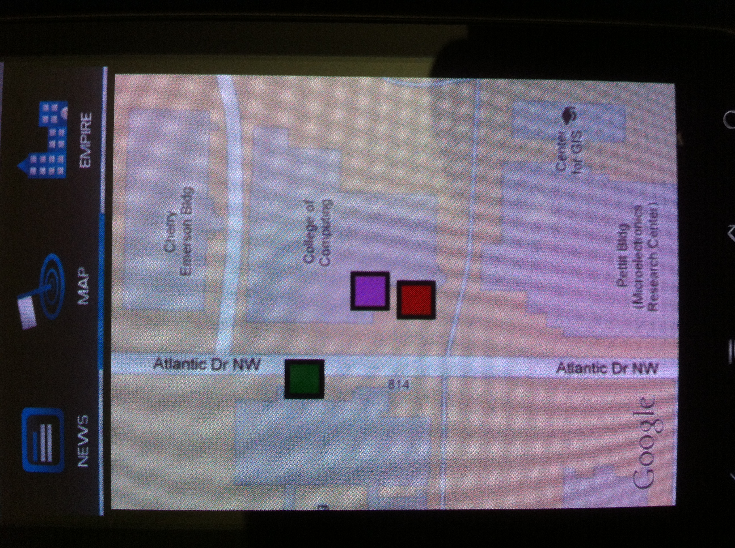

5.3 News Feed
The updates activity uses an PHP / XML configuration as well. The updates are parsed and supply the action done, the user who performed the action, and the affected building. A timestamp is also produced using PHP in a "2 days, 5 minutes, 11 seconds" format.

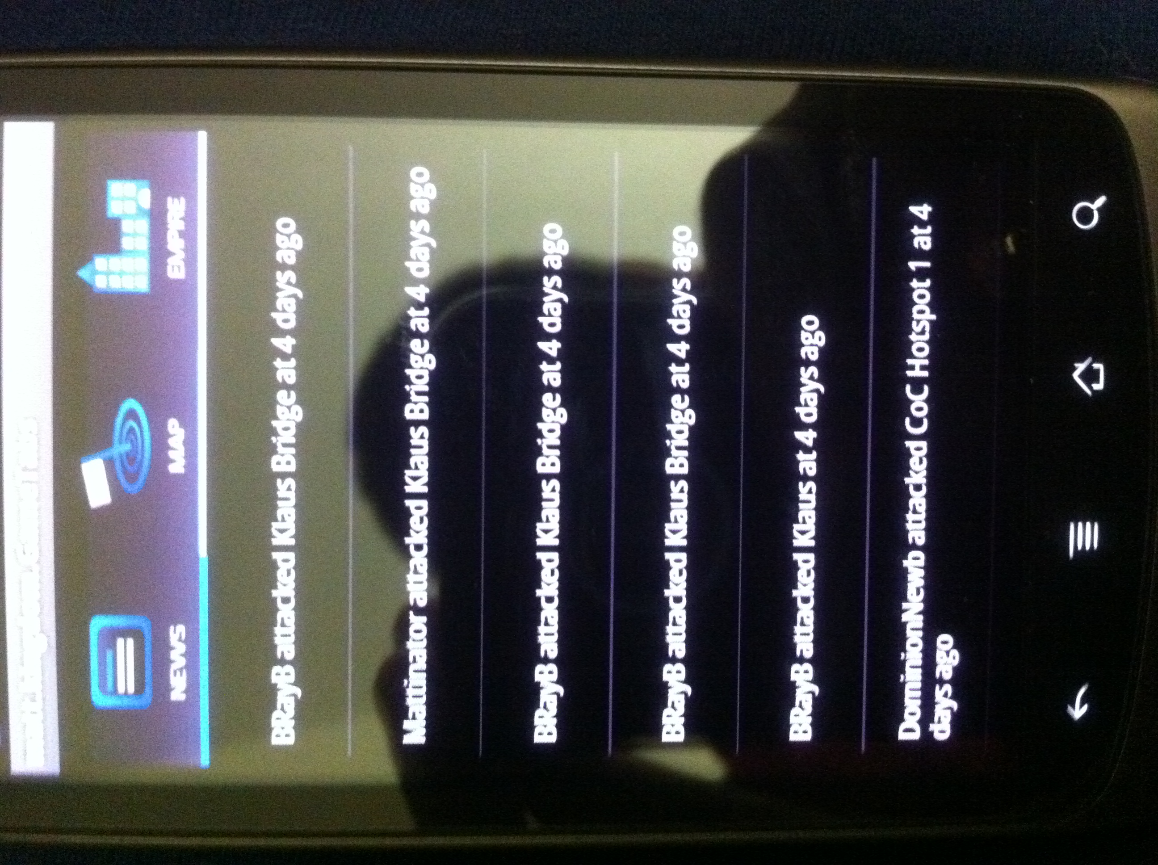

5.4 My Empire
The empire view uses a ListView to display the buildings and uses the same PHP / XML document to display the buildings, however they are specific to the ones owned by the player. The other information uses a different PHP file that constructs a simple XML document that contains the player's specific info including their EXP points, Element powers, and the location of their Attack and Life Tokens.

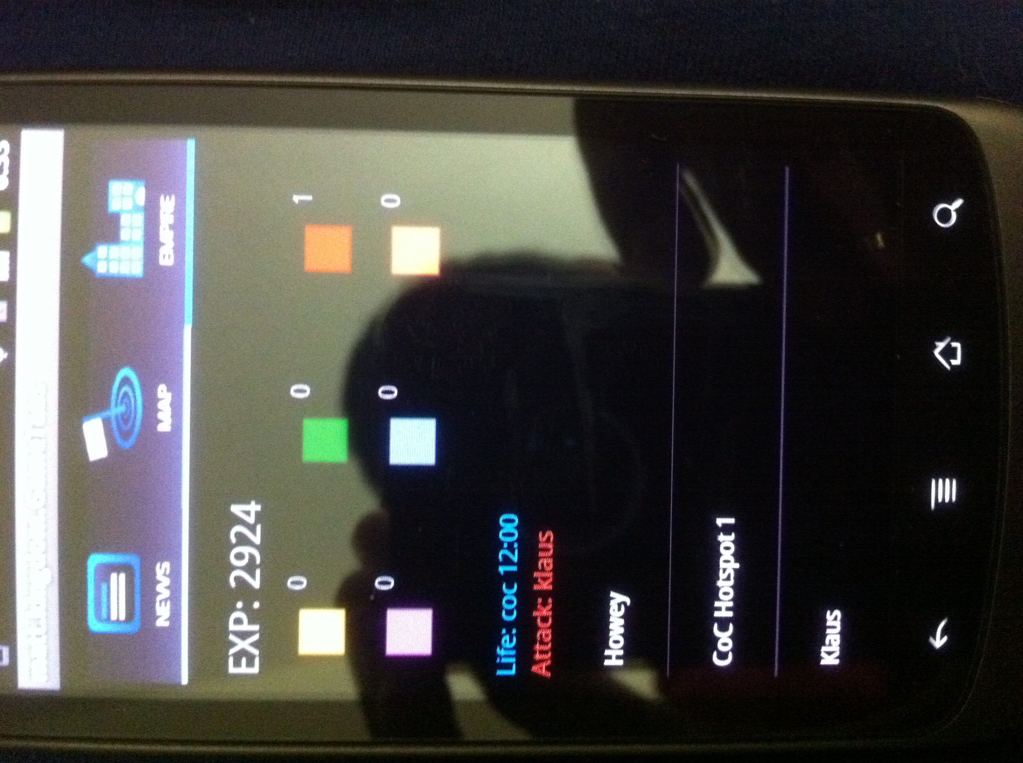

5.5 HTML5 Webpage
We chose to incorporate an HTML5 design rather then a Flash design for several reasons. First, Flash is very CPU intensive and relies on the user to download a 3rd party plugin, HTML5 is native to most modern browsers. Second, Actionscript is not difficult to develop in however, HTML5 decreases the amount of coding by being able to incorporate both Javascript and PHP directly on the page rather than having it in separated many ActionScript files and classes. Furthermore, HTML5 is more reliant and doesn't involve extensive work to make a slick and attractive design since HTML is a markup language and Flash is a vector based environment.

